Peer-graded Assignment: Capstone Project - The Battle of Neighborhoods (Week 1)

A.1 Introduction
Problem : An entrepreneur wants to open an Italian restaurant in one of New York City’s boroughs. He needs to know the strategic location for the restaurant .

Background & Problem Description
Investing in food for entrepreneurs is a lucrative business idea, according to experts. It has been noted that the greater part of the population of customers enjoy spoiling themselves and spending their money on food, of course good food!. In as much as other business ideas of interest like fashion, cosmetics, and hotels are gaining much popularity nowadays, none of them can’t match the long history of satisfied patrons that the food industry boasts of.
New York City has long been one of the most sought-after places to open a restaurant. A restaurant is a business which prepares and serves food and drink to customers in return for money, either paid before the meal, after the meal, or with an open account . Being the most populous city in the country with more than eight million people and counting; this means there is a lot of hungry mouths to feed, so it’s no wonder more and more restaurant owners are setting up shop. Data from the National Restaurant Association shows that there are almost 45,000 food establishments in New York City, so restaurant entrepreneurs can expect stiff competition. But there’s still room for business growth. Today, New York is home to many of the finest restaurants in the world — and New Yorkers have become accustomed to regularly dining out. The cuisine of New York City comprises many cuisines belonging to various ethnic groups that have entered the United States through the city. Almost all ethnic cuisines are well represented in New York, both within and outside the various ethnic neighborhoods New York City is composed of five boroughs, each of which is a county of the State of New York. The five boroughs—Brooklyn, Queens, Manhattan, the Bronx, and Staten Island. [Wikipedia]
It can be seen that New York City is ideal for the the food industry. There are important factors to consider before one opens a restaurant in New York City. One of the factors is the location of the restaurant from the five boroughs of New York City. Characteristics of the locations such as, population, type of restaurant, average income, tourist attraction , historical monuments etc can be used in the analysis of the neighborhoods.
Objective:The aim of this project is to help entrepreneurs planning to open a new Italian restaurant in New York City to chose the right location by :
- finding the most populated Borough in New York
- use geopy to obtain geographical location by address name of neighborhoods in the most populated Borough
- use Foursquare API to get ten most common venues and their respective categories in each neighborhood
- analyze the obtained information and come up with the best location
Proposed Solution: The neighborhoods in New York City are going to be reduced to boroughs of New York City . The most populated borough will be used for analysis. Geopy will be used to get geological location by address name and Foursquare API to get the venues' record of given venues of New York City.

A2. Data acquisition and cleaning
2.1 Data Sources
The data population data for each borough in New York City (2019 data set) was obtained from the data set found at this web site https://data.beta.nyc/dataset/0ff93d2d-90ba-457c-9f7e-39e47bf2ac5f/resource/7caac650-d082-4aea-9f9b-3681d568e8a5/download/nyc_zip_borough_neighborhoods_pop.csv". This data set has the following information: zip code, post office, borough name, neighborhoods’ names, population value and population density value for each and every neighborhood. The other data set that was used is found at the following address https://cocl.us/new_york_dataset. This data set contains borough names, neighborhood names, latitude and longitude values for each neighborhood .

2.2 Data cleaning
The data downloaded from both sources had no missing values or data types mismatch issues.
2.3 Feature selection
After downloading the data sets and converting them into pandas data frames, the data was analyzed. In the population data set, it was observed that most of the fields were not necessary for the analysis. This data set served the purpose of only identifying the borough in New York City that has the highest population. The image below shows the data frame created from the data set, after downloading data set.
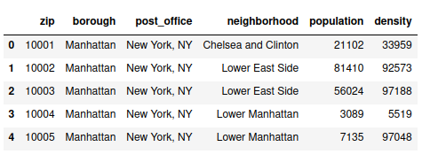

Fig 2.2a
The pandas idmax ( ) method was used to identify the borough with the highest population. This borough was found to be Queens and therefore was the one used for analysis since the restaurant has to be established in an area where there are likely to be more customers.
The next stage was to extract Queens’ data,that is, neighborhood name , latitude and longitude values. The image below shows the data frame with the information.
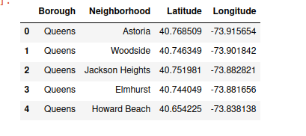

Fig 2.2b
After obtain this data frame, Geopy and Foursquare API were then used to obtain venue ,category information as well as coordinates information, for each neighborhood in Queens. The image below shows the created data frame.
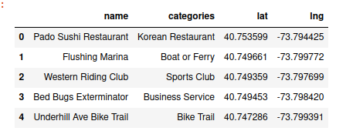

Fig 2.2c
The previous two data frames (Fig 2.2b and 2.2c) were then merged so that neighbors in Queens could be explored. Fig 2.2d shows the resulting data frame
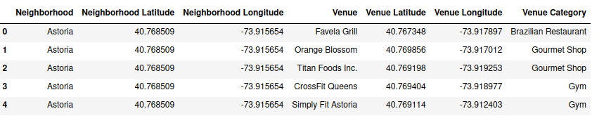
Fig 2.2d
The next step was to use onehot encoding on the above data so that it could be applied to a machine learning algorithm (Kmeans clustering) for further analysis. This resulted in the data frame below.
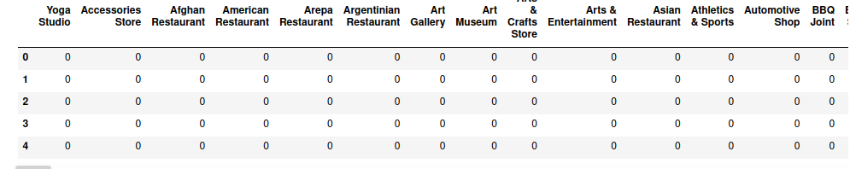
Fig 2.2e

B. Methodology
The downloaded data sets were stored on a GitHub repository as well as on my local machine. The first thing to do was to determine the borough with the highest population. This borough was considered to be ideal for analysis since it gives a good reflection on customer demographics to be considered when choosing the location for a restaurant.
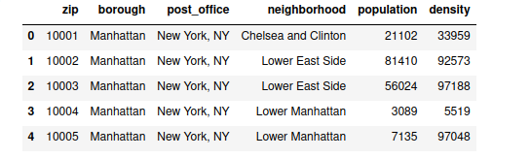
Choosing the borough for analysis
The idea is to find the location from a borough that is likely to have more customers. The simplest starting point for this is to identify the borough with the highest population and use it for analysis. Why?This is because more that 90% of people like to spend their money on food (Wikipedia).
The bar chart below shows the Boroughs alongside their population values.
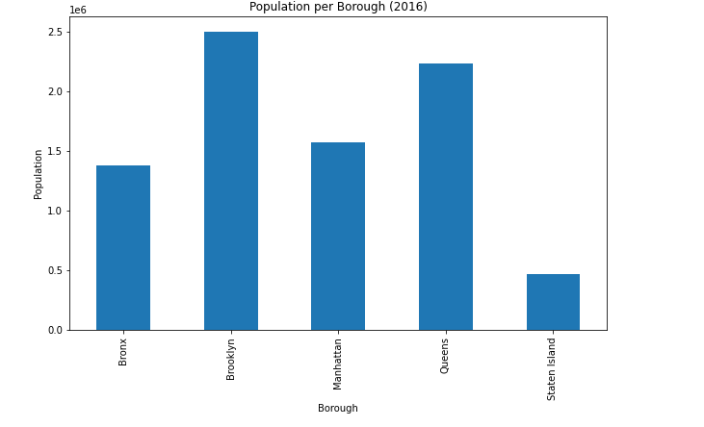

From the bar chart, it can be seen that Brooklyn is the Borough with the highest population.
Extracting Brooklyn Data
The next stage was to then extract the Brooklyn data only, information such as, neighborhood, latitude and longitude for each neighborhood in Brooklyn. Also geopy was used to get coordinates for Brooklyn.
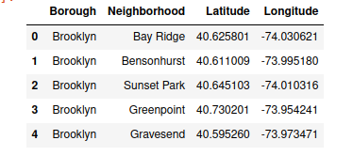

Analyzing Neighborhoods in Brooklyn
The next thing to do was to obtain the venue and category information for each venue. This was achieved using Foursquare API. The most popular spots for each neighborhood were considered. The number of the most popular spots extracted was limited to 100 within 500 m radius. The figure below shows the first five venues and their category returned by Foursquare.

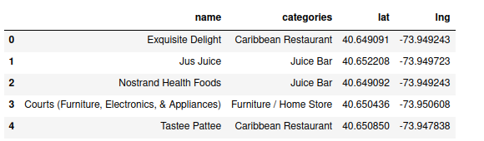
Foursquare was able to return only 30 venues.

To get more insight , the venues in Brooklyn were then explored alongside the respective neighborhoods. The resulting data frame after using Foursquare and merging precious results is shown below.
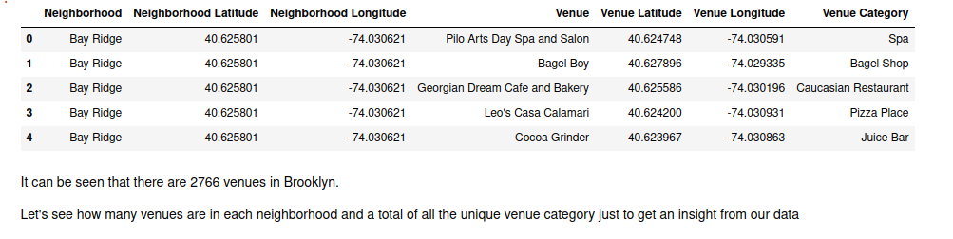
The next stage was to see how many venues are returned by each neighborhood so that one gets a picture of the distribution of venues across neighborhood. This also gave a picture of the number of categories per neighborhood. The resulting data frame is shown below.

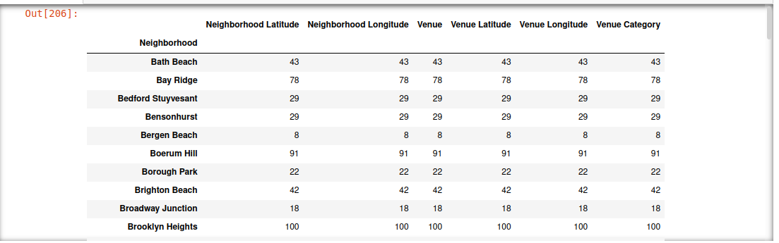
In total, it was discovered that there are 288 unique categories in Brooklyn.
Finding 10 most common venues in each neighborhood
This analysis involved finding 10 most common venues so that one can see how restaurants are common in Brooklyn. Grouping of the Brooklyn data set by neighborhood was done and the mean frequency for each category was found. The data frame below was obtained for the 10 most common venues.
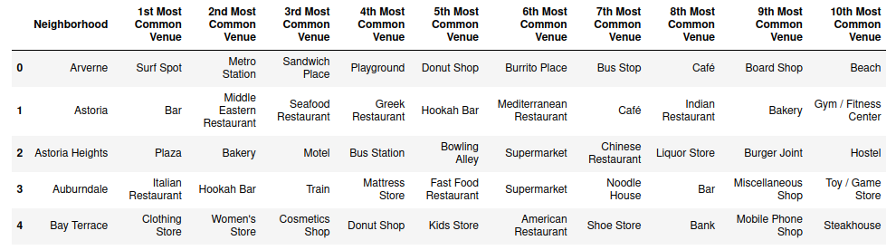
Grouping Restaurants
This stage involved extracting a list of all restaurants in Brooklyn and putting them in a data frame. It also involve counting the different types of restaurants in Brooklyn to see how they are distributed. Then a bar chart was plotted to see which type of restaurants have the highest frequency . The chart is shown below.
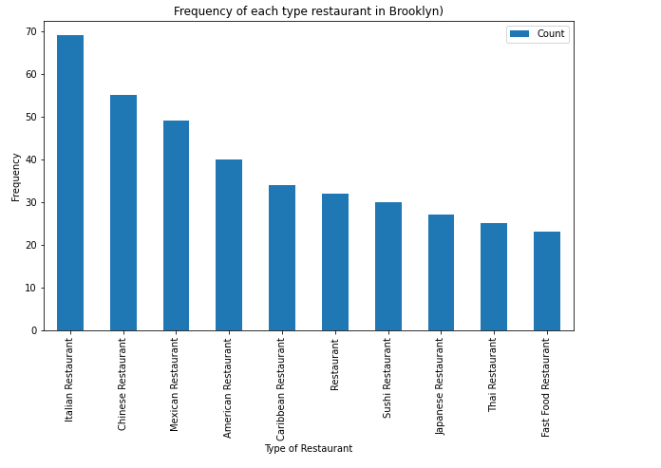

It can be seen that Italian Restaurant has the highest frequency.
Clustering the Restaurants
One hot encoding was applied to the restaurant data frame so that later on it will be parsed to a machine learning algorithm. The restaurants were grouped to find the restaurants which are in the 10 Most Common Venues in their neighborhoods
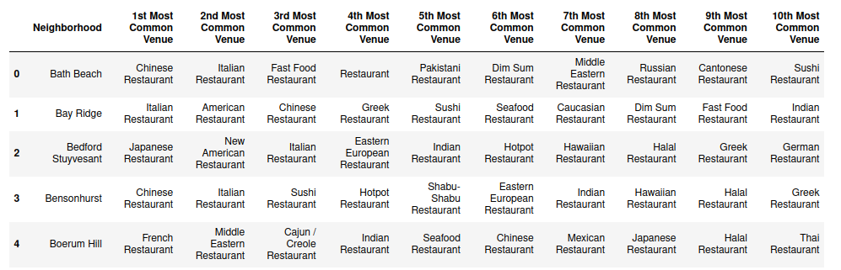
These restaurants were then clustered so that each cluster could be examined and analyzed individually. K-means scattering was used. The Elbow method was used to determine the optimum value for k. The diagram below shows the output.
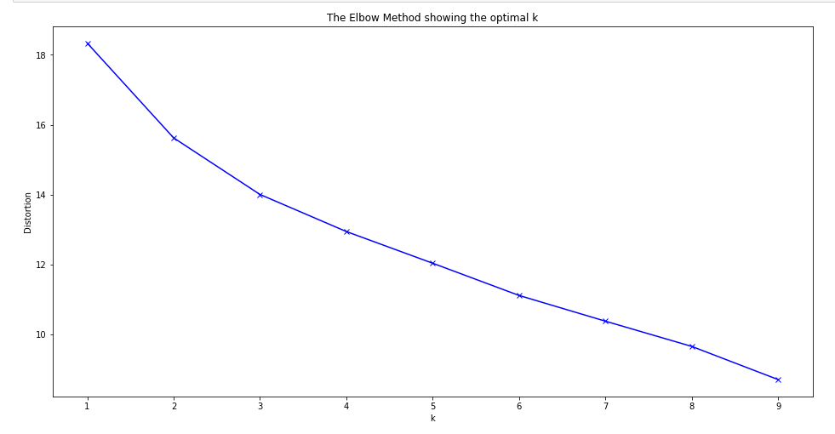
From the above diagram, it can be seen that an optimum value for k is 3. Therefore k-means clustering was run with k=3.
The output after clustering is shown below. This shows the restaurants found in the first 10 most common venues, in Brooklyn.
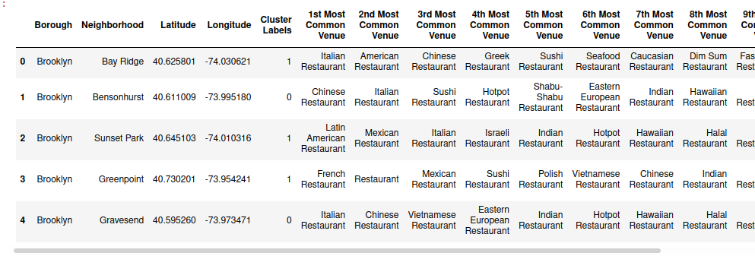
Analysis of the restaurant clusters
The first stage here involved visualizing these clusters on a map obtained by using folium as shown below.
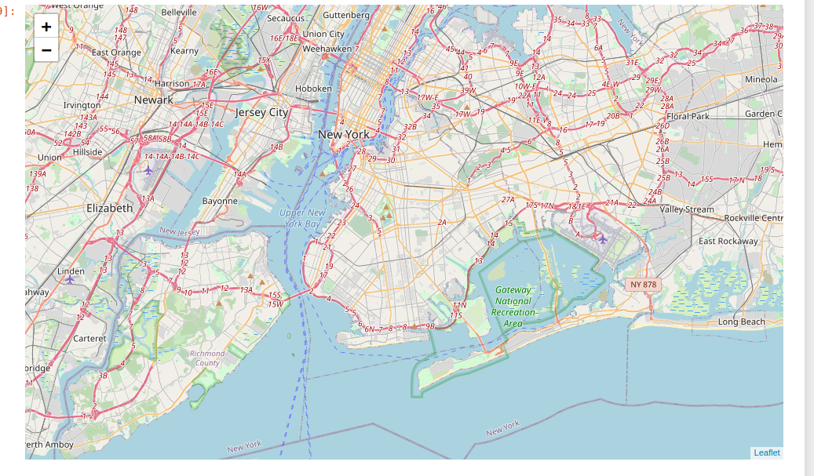
The three clusters are shown by the dotted circles around each cluster. It can be seen that the clusters are generally big.

The second stage involved analyzing each and every cluster to get more insight. This stage involved checking the following:
- If an Italian Restaurant is the list of most common venues
- Number of Italian Restaurants in each cluster
- Total number of restaurants in a cluster
The outcomes of this analysis are shown in the result section

C. Results
These are the results obtained after analyzing each and every cluster from which the location will be determined.
Cluster 1
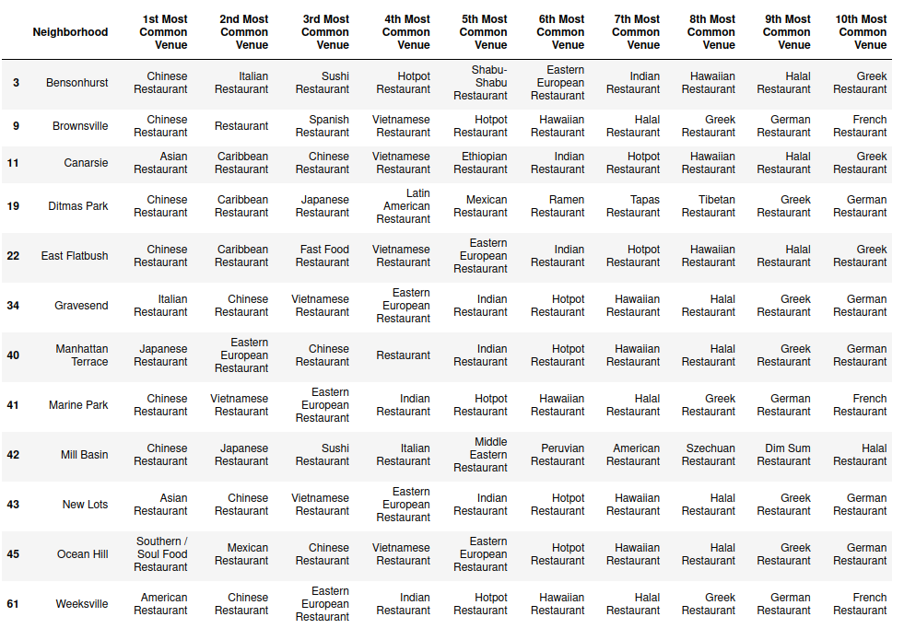

Cluster 1 has a total of 120 restaurants. However, there are only three Italian restaurants in this cluster as shown by the image below.
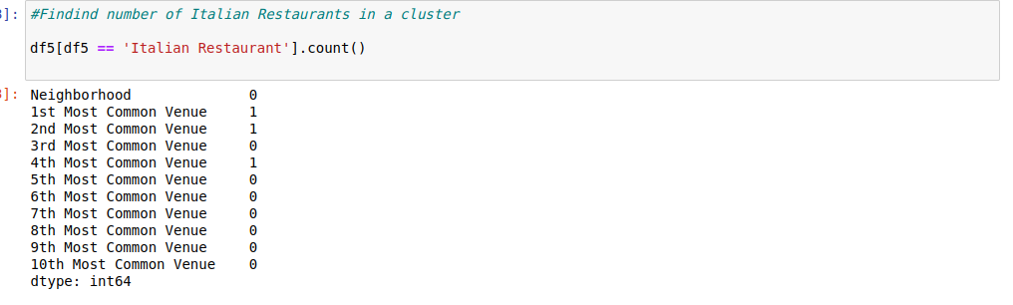

Having 3 Italian Restaurants out of 120 restaurants shows that Italian Restaurant are not very common in this cluster though they top the first 2 Most Common Venues. Cluster 1 is not ideal for a good location because it seems like the clientele is not that much.
Cluster 2

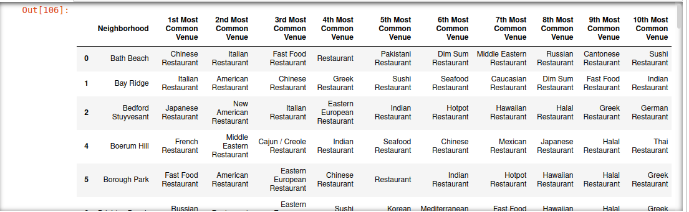
Cluster 2 has the highest number of restaurants, 174 . There are 25 Italian Restaurants in this cluster and 8 of them are the 1st Most Common Venues. The 2nd Most Common Venue has 5 Italian Restaurants. The 3rd most common venue also have 5 Italian Restaurants. Clearly, Italian food has a lot of customers in this cluster and it appears like Italian Restaurants are among-st the 1st top venues in this cluster. Neighborhoods with Italian Restaurants as the 1st most common venue are ideal places for the location of the restaurant.
The statistics of cluster 2 is shown in the image below.
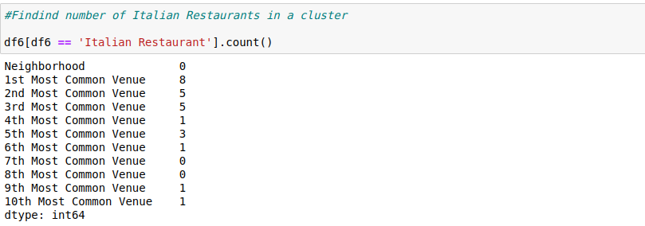
Cluster 3

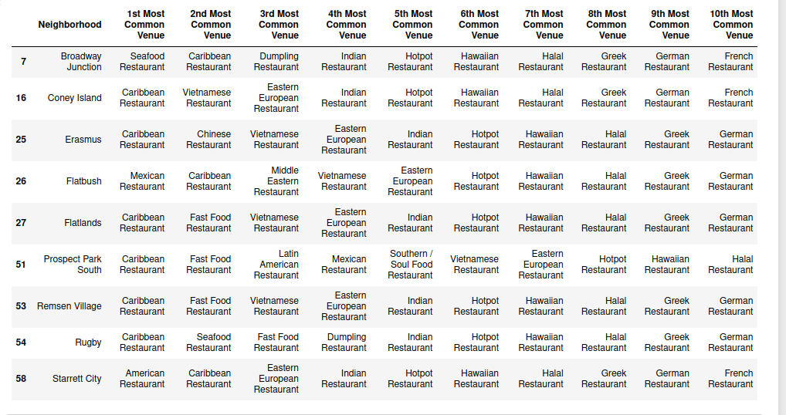
Cluster 3 has a total of 90 restaurants and there isn’t even a single Italian Restaurant in cluster 3.
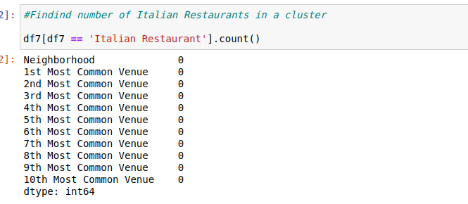

D. Discussion
From the above analysis, it was observed that restaurants are definitely a common business in Brooklyn. This is supported by the fact that more that 90% of people love to spoil themselves with food. This research was a market driven idea. The idea was to find a location where restaurants and Italian Restaurants are a very common business. Therefore, the Brooklyn was chosen based on its highest population (implying more demographics factors). The next thing was to cluster restaurants and an analysis was made from the clusters.

Cluster 2 had the highest number of Italian restaurants and eight of them were in the 1st Most Common Venue. This cluster clearly shows that Italian food is common, probably there are a lot of Italian food lovers in the cluster. Moreover, having a lot of Italian restaurants in it means there is already a ready market for Italian food. Neighborhoods in which an Italian Restaurant was the 1st most common venue can be considered as potential locations for the restaurant.

Of course, it doesn't mean that the approach used in this project is the best way to find a location for a restaurant. There are other factors that can be considered such as,general air and environmental pollution, quietness of the neighborhood, age groups in the neighborhood, distance of neighborhood from central point, etc. However, from a clientele perspective, it is wiser to start a business where a market already exists and survival will depend on quality of services offered.
E. Conclusion and future recommendations.
The main objective of the project was to find a location for an Italian restaurant in New York City, using Foursquare API. The most populated borough, Brooklyn was used for analysis. All restaurants were grouped into three clusters using k-means clustering and each cluster was analyzed. This approach alongside others, such as finding distance of each venue from the central position in a neighborhood, considering other factors such as age groups of inhabitants, nationalities, etc can be used to find the location for a new restaurant.

